Q1.

CREATE SEQUENCE CustomerID_seq

START WITH 4 -- Assuming you already have customers with IDs 1, 2, and 3

INCREMENT BY 1

NOCACHE

NOCYCLE;

/

CREATE OR REPLACE PACKAGE CustomerManagement AS

-- Procedure to add a new customer

PROCEDURE AddCustomer(

p_Name IN VARCHAR2,

p_DOB IN DATE,

p_Balance IN NUMBER

);

-- Procedure to update customer details

PROCEDURE UpdateCustomer(

p_CustomerID IN NUMBER,

p_Name IN VARCHAR2,

p_DOB IN DATE,

p_Balance IN NUMBER

);

-- Function to get customer balance

FUNCTION GetCustomerBalance(

p_CustomerID IN NUMBER

) RETURN NUMBER;

END CustomerManagement;

/

CREATE OR REPLACE PACKAGE BODY CustomerManagement AS

-- Implementation of AddCustomer procedure

PROCEDURE AddCustomer(

p_Name IN VARCHAR2,

p_DOB IN DATE,

p_Balance IN NUMBER

) IS

v_CustomerID NUMBER;

BEGIN

-- Generate a new unique CustomerID

SELECT CustomerID_seq.NEXTVAL INTO v_CustomerID FROM DUAL;

-- Insert the new customer into the Customers table

INSERT INTO Customers (CustomerID, Name, DOB, Balance, LastModified)

VALUES (v_CustomerID, p_Name, p_DOB, p_Balance, SYSDATE);

COMMIT;

EXCEPTION

WHEN OTHERS THEN

ROLLBACK;

RAISE_APPLICATION_ERROR(-20001, 'Error adding customer: ' || SQLERRM);

END AddCustomer;

-- Implementation of UpdateCustomer procedure

PROCEDURE UpdateCustomer(

p_CustomerID IN NUMBER,

p_Name IN VARCHAR2,

p_DOB IN DATE,

p_Balance IN NUMBER

) IS

BEGIN

UPDATE Customers

SET Name = p_Name, DOB = p_DOB, Balance = p_Balance, LastModified = SYSDATE

WHERE CustomerID = p_CustomerID;

COMMIT;

EXCEPTION

WHEN OTHERS THEN

ROLLBACK;

RAISE_APPLICATION_ERROR(-20002, 'Error updating customer: ' || SQLERRM);

END UpdateCustomer;

-- Implementation of GetCustomerBalance function

FUNCTION GetCustomerBalance(

p_CustomerID IN NUMBER

) RETURN NUMBER IS

v_Balance NUMBER;

BEGIN

SELECT Balance INTO v_Balance

FROM Customers

WHERE CustomerID = p_CustomerID;

RETURN v_Balance;

EXCEPTION

WHEN NO_DATA_FOUND THEN

RAISE_APPLICATION_ERROR(-20003, 'Customer not found.');

WHEN OTHERS THEN

RAISE_APPLICATION_ERROR(-20004, 'Error retrieving balance: ' || SQLERRM);

END GetCustomerBalance;

END CustomerManagement;

/

*Output:*

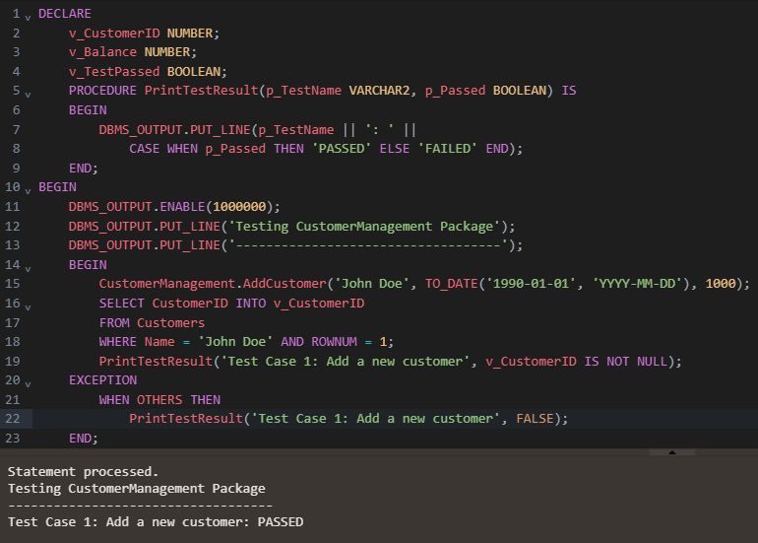

Q2.

CREATE OR REPLACE PACKAGE EmployeeManagement AS

PROCEDURE HireEmployee(

p_EmployeeID NUMBER,

p_Name VARCHAR2,

p_Position VARCHAR2,

p_Salary NUMBER,

p_Department VARCHAR2,

p_HireDate DATE

);

PROCEDURE UpdateEmployeeDetails(

p_EmployeeID NUMBER,

p_Name VARCHAR2 := NULL,

p_Position VARCHAR2 := NULL,

p_Salary NUMBER := NULL,

p_Department VARCHAR2 := NULL

);

FUNCTION CalculateAnnualSalary(

p_EmployeeID NUMBER

) RETURN NUMBER;

END EmployeeManagement;

/

CREATE OR REPLACE PACKAGE BODY EmployeeManagement AS

PROCEDURE HireEmployee(

p_EmployeeID NUMBER,

p_Name VARCHAR2,

p_Position VARCHAR2,

p_Salary NUMBER,

p_Department VARCHAR2,

p_HireDate DATE

) IS

BEGIN

INSERT INTO Employees (EmployeeID, Name, Position, Salary, Department, HireDate)

VALUES (p_EmployeeID, p_Name, p_Position, p_Salary, p_Department, p_HireDate);

END HireEmployee;

PROCEDURE UpdateEmployeeDetails(

p_EmployeeID NUMBER,

p_Name VARCHAR2 := NULL,

p_Position VARCHAR2 := NULL,

p_Salary NUMBER := NULL,

p_Department VARCHAR2 := NULL

) IS

BEGIN

UPDATE Employees

SET

Name = NVL(p_Name, Name),

Position = NVL(p_Position, Position),

Salary = NVL(p_Salary, Salary),

Department = NVL(p_Department, Department)

WHERE EmployeeID = p_EmployeeID;

END UpdateEmployeeDetails;

FUNCTION CalculateAnnualSalary(

p_EmployeeID NUMBER

) RETURN NUMBER IS

v_Salary NUMBER;

BEGIN

SELECT Salary INTO v_Salary

FROM Employees

WHERE EmployeeID = p_EmployeeID;

RETURN v_Salary * 12;

END CalculateAnnualSalary;

END EmployeeManagement;

/

*Output:*

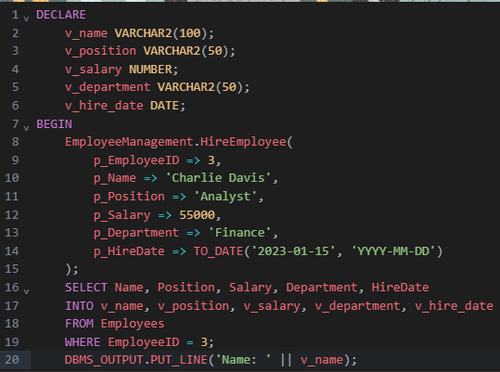

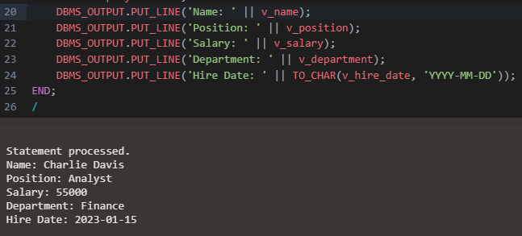

Q3.

CREATE OR REPLACE PACKAGE AccountOperations AS

PROCEDURE OpenAccount(

p_AccountID NUMBER,

p_CustomerID NUMBER,

p_AccountType VARCHAR2,

p_Balance NUMBER

);

PROCEDURE CloseAccount(

p_AccountID NUMBER

);

FUNCTION GetTotalBalance(

p_CustomerID NUMBER

) RETURN NUMBER;

END AccountOperations;

/

CREATE OR REPLACE PACKAGE BODY AccountOperations AS

PROCEDURE OpenAccount(

p_AccountID NUMBER,

p_CustomerID NUMBER,

p_AccountType VARCHAR2,

p_Balance NUMBER

) IS

BEGIN

INSERT INTO Accounts (AccountID, CustomerID, AccountType, Balance, LastModified)

VALUES (p_AccountID, p_CustomerID, p_AccountType, p_Balance, SYSDATE);

END OpenAccount;

PROCEDURE CloseAccount(

p_AccountID NUMBER

) IS

BEGIN

DELETE FROM Accounts

WHERE AccountID = p_AccountID;

END CloseAccount;

FUNCTION GetTotalBalance(

p_CustomerID NUMBER

) RETURN NUMBER IS

v_TotalBalance NUMBER;

BEGIN

SELECT SUM(Balance)

INTO v_TotalBalance

FROM Accounts

WHERE CustomerID = p_CustomerID;

RETURN NVL(v_TotalBalance, 0);

END GetTotalBalance;

END AccountOperations;

/

*Output:*

